MARKET RESEARCH & INVESTMENT STRATEGY REPORT

Finance & Investment Analysis Internship

CodeAlpha

Submitted By:
Name:T.M.Leena Sree

Internship Domain:

Finance & Investment Analysis

Task:

Task 4 – Mini Project

Submission Date:
May 2026

Introduction
Investment analysis helps investors understand market trends, evaluate risks, and identify future growth opportunities. In recent years, both stock markets and cryptocurrencies have gained significant attention among investors worldwide.
This report compares stock market and cryptocurrency trends, explains risk management strategies in investments, and analyzes the future outlook of selected investment sectors. The report also highlights the importance of diversification and informed decision-making in financial investments

Stock Market vs Cryptocurrency Trends
The stock market represents ownership in companies and is considered a relatively stable investment option for long-term growth. Stocks are regulated by government authorities and are influenced by company performance, economic conditions, and market trends.
Cryptocurrency is a digital asset based on blockchain technology. Cryptocurrencies such as Bitcoin and Ethereum have shown rapid growth and high volatility in recent years. Unlike stocks, cryptocurrencies are decentralized and experience larger price fluctuations.

Comparison Table
Feature | Stock Market | Cryptocurrency
Stability | More Stable | Highly Volatile
Regulation | Government Regulated | Limited Regulation
Risk Level | Moderate | High
Returns | Stable Long-Term | High Short-Term Potential
Market Timing | Fixed Trading Hours | 24/7 Trading

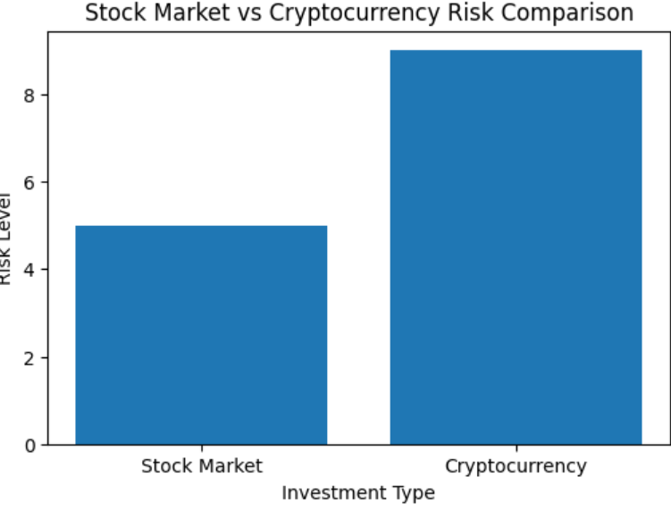

Risk Management in Investments
Risk management is an important part of successful investing. Investors use different strategies to reduce losses and improve financial stability.

Common Risk Management Strategies
- Diversification across different sectors
- Long-term investment planning
- Avoiding emotional trading
- Regular portfolio monitoring
- Investing according to risk tolerance
Diversification helps investors reduce overall investment risk by spreading investments across stocks, cryptocurrencies, ETFs, and other assets.

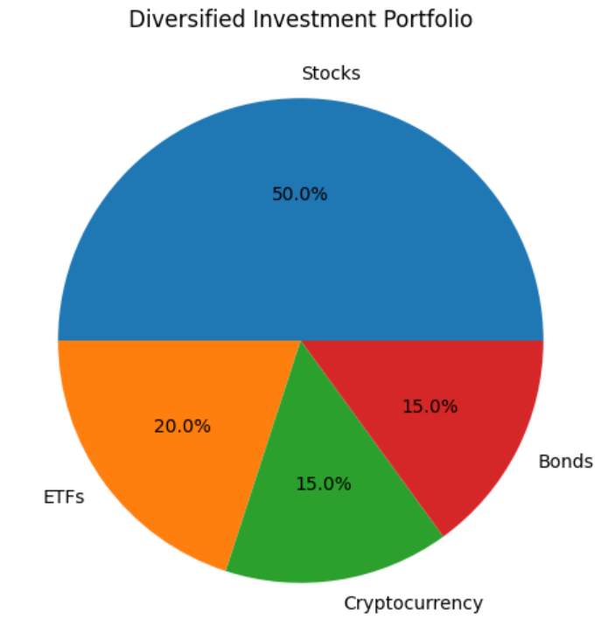

Future Outlook of Investment Sectors
Several investment sectors are expected to experience strong future growth due to technological advancements and changing consumer demand.

Promising Investment Sectors

Technology Sector
Growth in artificial intelligence, cloud computing, and cybersecurity is increasing investment opportunities in technology companies.

Electric Vehicle Sector
The demand for electric vehicles and clean energy solutions is expected to grow rapidly in the coming years.

Renewable Energy Sector
Governments and companies are investing heavily in solar, wind, and sustainable energy projects.

Digital Finance & Cryptocurrency
Blockchain technology and digital payment systems continue to expand globally, increasing interest in cryptocurrencies and digital assets.

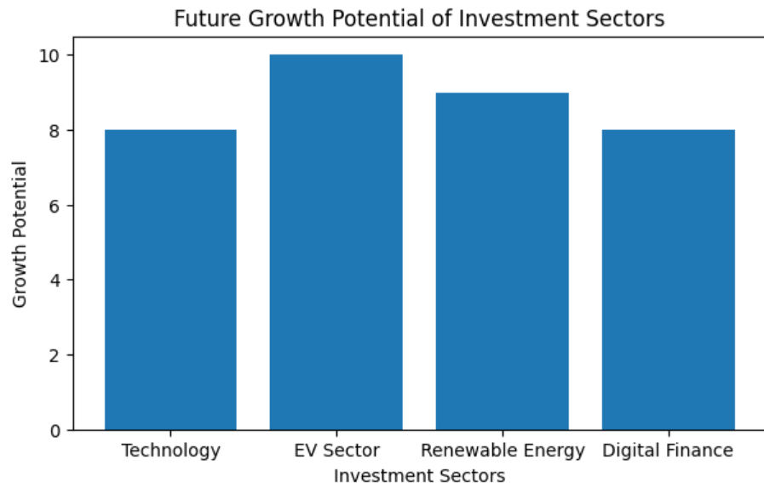

Conclusion
The comparison between stock markets and cryptocurrencies highlights different investment opportunities and risk levels. Stocks provide relatively stable long-term growth, while cryptocurrencies offer higher return potential with greater market volatility.
Effective risk management and diversification are essential for making informed investment decisions. Future investment opportunities are expected to grow in sectors such as technology, electric vehicles, renewable energy, and digital finance.

References
• Yahoo Finance
• Moneycontrol
• Investopedia
• CoinMarketCap
• NSE India

